A4117-Asia-China-Shang-Gong-Argali-Mountain Sheep-Bronze-1766-1122 BCE

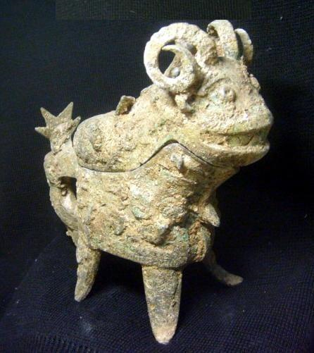

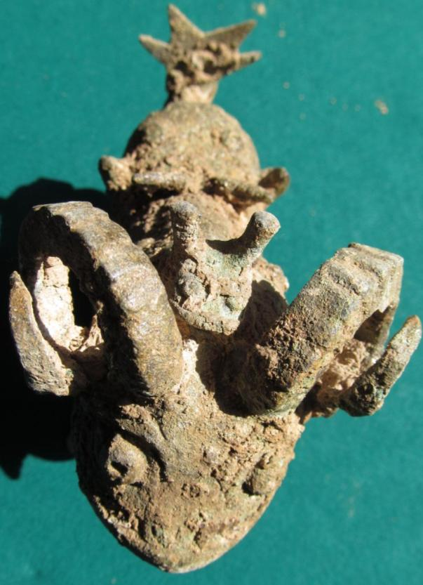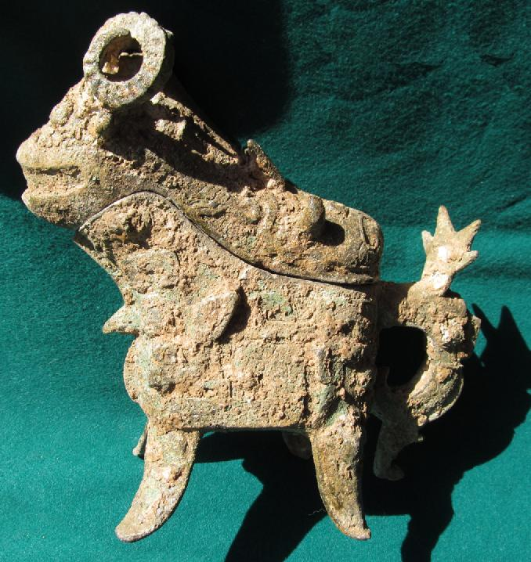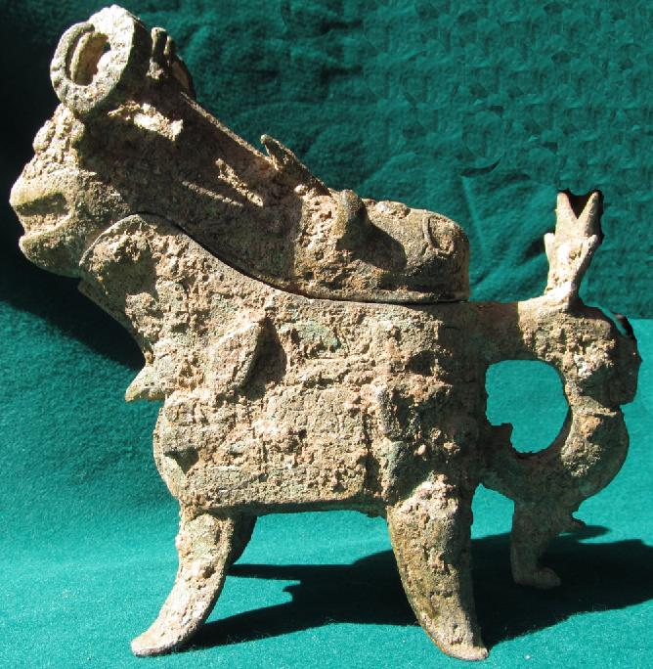

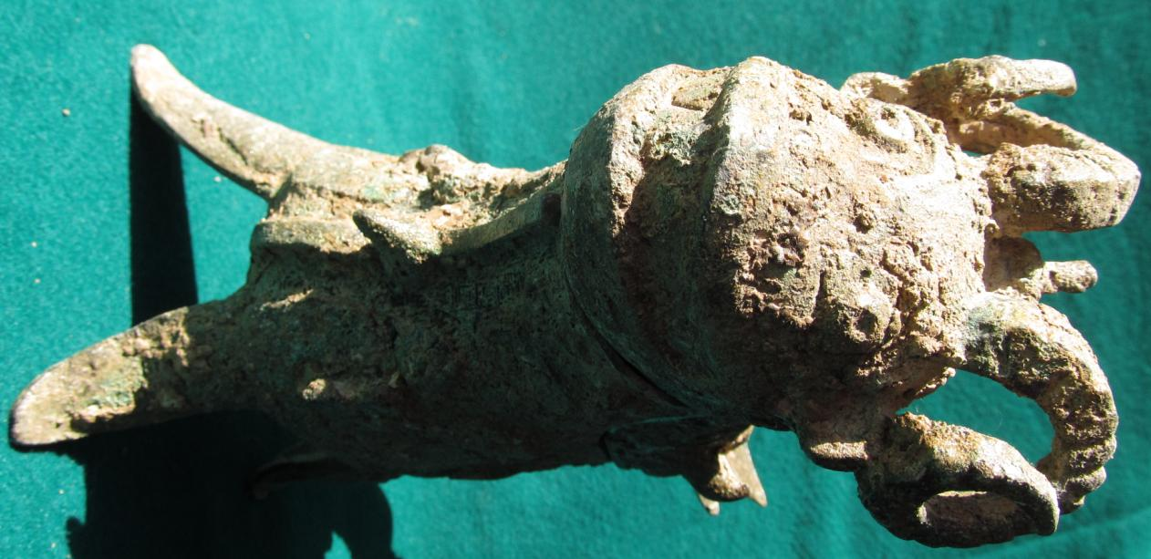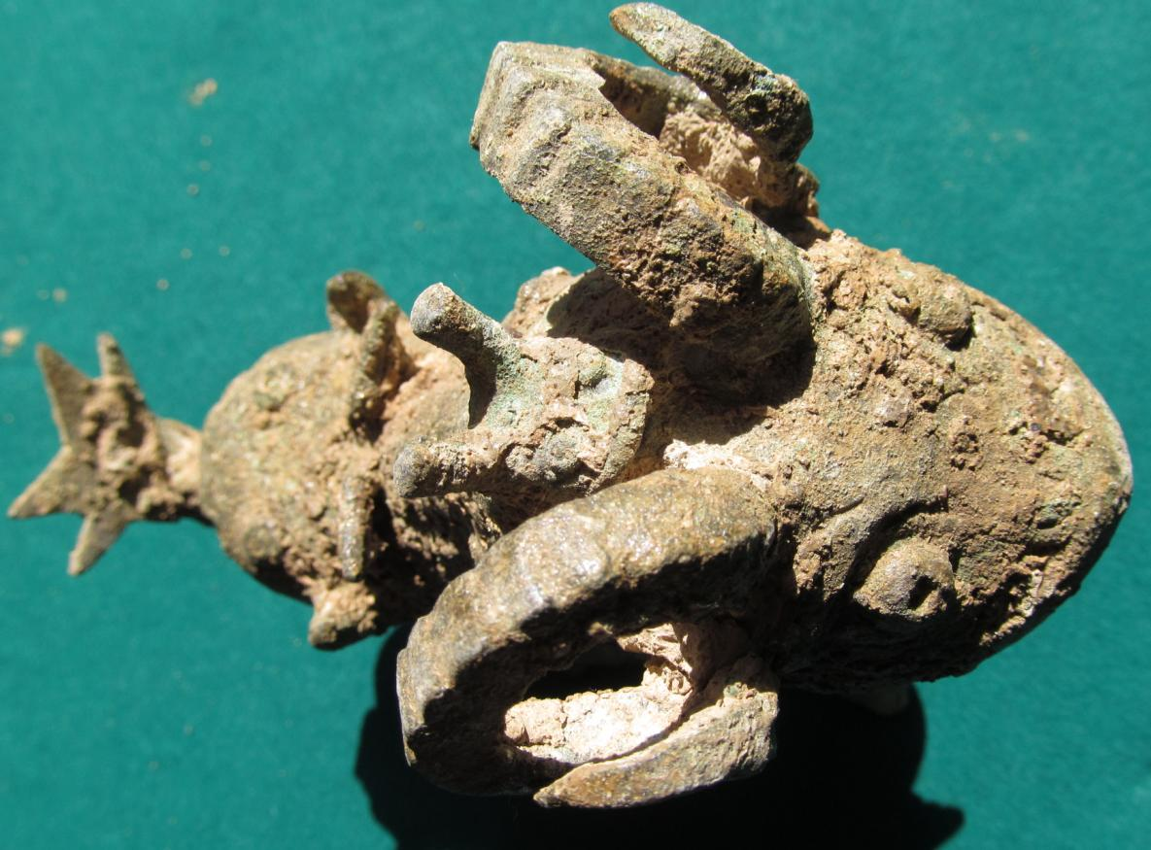

Argali, main figure, with Muntjak surmounted.

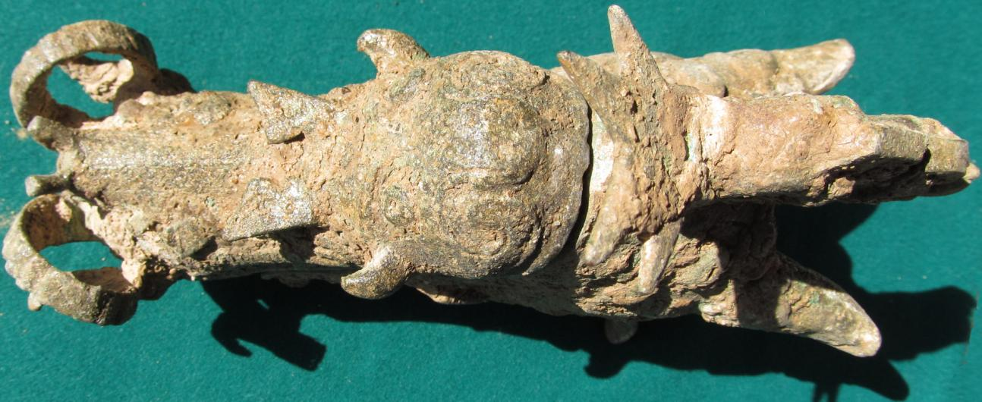

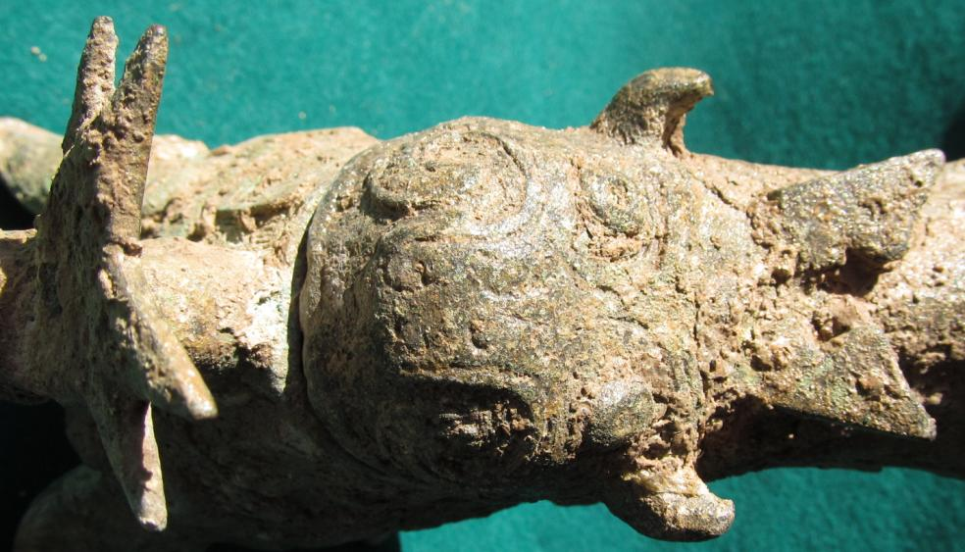

Asia-China-Shang-Gong-Argali-Mountain Sheep-Bronze-1766-1122 BCE

**Case No.: 5**

**Accession No.**

**Formal Label:** Asia-China-Shang-Gong-Argali-Mountain Sheep-Bronze-1766-1122 BCE

**Display Description:**

The lid is shaped like a dragon with a toothygrin and protruding horns, while the handle forms another beast. Two demon masks (*taotie*) with horns, fangs, and bulging eyes decorate the sides, while another two are found under the chin and tail of the beast. In total, twenty dragons, birds, and mythical creatures morph into each other on the lid and body of the bronze. They illustrate the spiritual transformation that the ancient Chinese believed occurs when communicating with ancestors, or when leaving this world for the afterlife to become an ancestor oneself as would become a shaman. Such vessels were used for pouring wine offerings on ancestral altars or in ritual banquets by Shang kings, who served as the link between the living and their ancestors. The wine may also have had an effect on the transformation into one’s animal master.

This kong 觥(wg kung1) is a ritual wine pitcher in the shape of an argali or mountain sheep dating to the Bronze Age of China. It also is decorated with motifs of various animals, both real and imaginary.

The argali was probably chosen as the animal model for this vessel because it is the largest of wild sheep. The argali are a species (4 ft high at the shoulder) that inhabits areas with elevations of 300 to 5,800 m (980 to 19,000 ft) – often inaccessible mountainous retreats, suggestive of the places that shamans would resort to in quest of a communion with the heavenly spirits. The argali roams the Central Asian Highlands from central Kazakhstan in the west to the Shansi Province in China in the east and from the Altai Mountains in the north to the Tibetan Plateau and the Himalayas in the south. Throughout this region the argali is viewed as a species that communicates with the numinous on the lofty peaks it roams.

**LC Classification:** [NK7983](https://catalog.princeton.edu/cgi-bin/Pwebrecon.cgi?v1=127&ti=101,127&Search%5FArg=shang%20bronzes&Search%5FCode=GKEY%5E&CNT=50&PID=pKVneWLtQXoVqZpf1GkbO3sALpiha&SEQ=20180113121113&SID=1)

**Date or Time Horizon:** **1766-1122 BCE**

**Geographical Area:** Henan Province, possibly Anyang

**Map:**

**GPS coordinates:**

**Cultural Affiliation:**

**Medium:** bronze

**Dimensions:**

**Weight:**

**Condition:**

**Provenance:**

**Discussion:**

**References:**

References: Allan, Sarah. 1991. The shape of the turtle: myth, art, and cosmos in early China, SUNY series in Chinese philosophy and culture, Schenectady: SUNY Press.